1.24: With a pulse rate of a bit more than one beat per second, a heart will beat 10⁵ times per day. With 365 days in a year and the above lifespan of 80 years, the number of beats in a lifetime is about 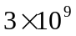. With 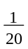 L (50 cm³) per beat, and about gallon per liter, this comes to about 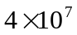 gallons.

